Modelling Data in Power BI Desktop

# Exercise 3

Right now, some columns are not directly useful for analysis because they contain concatenated values. A good example is the Genre column:

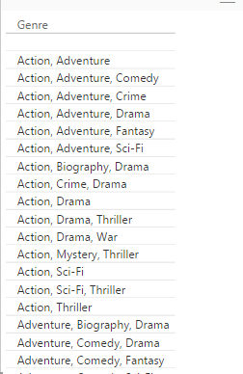

If we want to analyze all action movies, we must select 15 different genre combinations! To solve this issue, we’re going to create a many to many relationship in our model. This needs a little more work in the query engine. Go back to the queries and right-click on the source query. Let’s create a reference to this query.

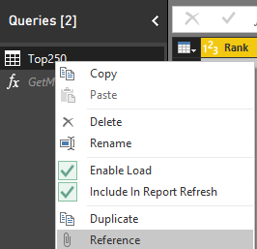

This will create a new query, with the output of the first query as the first step. First, we are going to create our bridge table for the M2M relationship. This table contains all combinations of the movie titles and their genres.

* Remove all columns except Title and Genre.
* Split out the Genre column using a delimiter.
* Unpivot the genre columns.
* Trim the genre column to remove spaces.

The result should look like this:



The next step is to create a table with the distinct values of Genre. Reference the bridge table into another new query.

* Remove the Title column
* Keep only the distinct values of the Genre column.

Load all data to the model. Because the queries actually reference the source query with the web service, it can take some time to load the data (caching could be improved here by Microsoft).

The model was smart enough to auto-detect the relationships:

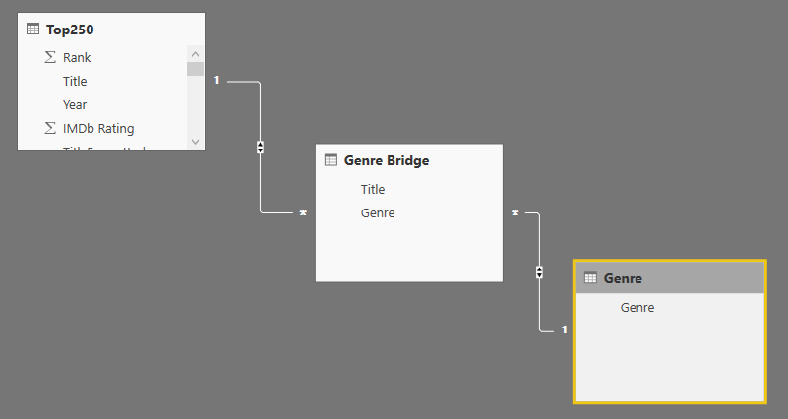

The default is to set all relationships to bi-directional cross-filtering. This can be overkill sometimes. Set the relationship between the genre table and the bridge to a normal relationship.

# Exercise 4

Open the file Start-Ex4.pbix. Several M2M relationships have been added to the model. Create the necessary relationships. When this is done, hide the bridge tables. In the IMDB Top 250 table, hide all the columns that are no longer necessary (such as Genre, Director …).

The result:

